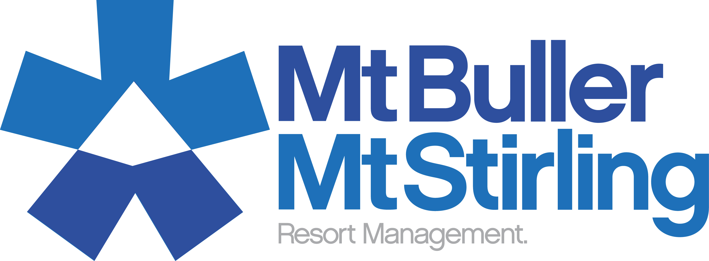
Fact Sheet
Recycled Water Used For Snow Making at Mt Buller
Mt Buller is the first alpine resort in the world to implement a system that enables it to use recycled water for snowmaking. The $3.43 million Water Reuse project is a great achievement for the resort and evidence of Mt Buller’s commitment to the longevity of the snow season. Here are some fast facts about the project and its benefits:
- The new Water Reuse system enables Mt Buller to recycle up to 2 million litres of waste water per day.
- The waste water is treated by a stringent disinfection process that results in the production of Class A recycled water. Class A is the highest achievable standard in recycled water.
- Class A water is commonly used on human food crops, for irrigating public spaces such as parklands and golf courses, and for many other every day purposes.
- The treatment of Mt Buller’s recycled water benefits the local environment by improving the quality of run-off that enters surrounding areas and water ways.
- The Water Reuse system is monitored 24 hours a day, seven days a week, to ensure that it produces a safe and consistent quality of water.
- The Water Reuse infrastructure is fitted with a fail-safe devise that means if anything within the system malfunctions, it automatically stops all operations to eliminate the possibility of untreated water being pumped into the snowmaking dam.
- Mt Buller’s recycled water is deposited in the Sun Valley Reservoir, significantly increasing the level of water in this snowmaking dam.
- More water means more man made snow, with the growth in water supply increasing Mt Buller’s snow making capacity by 30%.
- Snow that is made from recycled water looks and feels the same as all other man made snow.
- If snow made from recycled water is ingested, it will not have any significant health implications. However, just like natural snow, once it hits the ground it is vulnerable to contamination by animals, vehicles and other skiers, so should not be eaten.
- In the future, Mt Buller aims to also use this recycled water for household use in new developments and for irrigating open spaces to deliver further benefits to the local alpine environment.

If you have any queries about Mt Buller’s recycled water, please contact Resort Management on 03 5777 6077 or info@mtbuller.com.au

